Checklist Impression taking

Identium (Vinylsiloxanether – VSXE)

Identium was specially developed for the one-step impression technique and combines the best of both worlds: the advantages of polyether coupled with those of A-silicones.

Due to its highly elastic properties Identium exhibits dimensionally accurate recovery and allows very easy removal. It is also odorless and has a neutral taste.

Identium Medium and Heavy are besides fabricating crowns/bridges etc. also ideal for implant impressions - thanks to their high final hardness of Shore A 60.
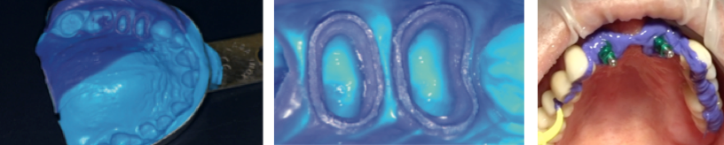

Identium Heavy, Medium and light are also available as Fast set!

Observe the following precautions prior to impression taking
Ensure that the ‘practice team’ know what to do and when to do it - create a clearly defined protocol for this. Certain external factors may adversely affect the setting of the impression material, such as liquids or solutions that may be used in conjunction with retraction cords, impression syringes that may still contain traces of polyether materials, the use of latex gloves and exceptionally warm working and storage areas.

Be sure to have appropriate medicaments on hand to control any ‘bleeding’ that may occur intra-orally. Blood can often be the cause of failed impressions.

Remains of methacrylate-based materials (temporary crowns and bridges) on the preparation(s) may change the setting properties of impression material. If so clean the preparation thoroughly or even better, first impression taking followed by the fabrication of the temporary crown or bridge.

Select impression tray
Selection of the correct impression tray is most important. Optimal dynamic pressure, stability and fit are essential in producing an accurate impression. It is recommended that light and medium viscosity materials be used in a ‘closed’ tray. Heavy-bodied materials will also benefit from this, especially when using a one-step technique.

Ensure there is sufficient space between the tray and residual dentition, particularly if there are undercuts! (Approx. 4 mm)

Prepare impression tray
To gain maximum dynamic pressure and to avoid displacement of material distally, the tray can be extended / individualized.

To avoid pressing through the impression material and also to ensure correct positioning of the tray in the mouth, it is advisable to create “impression stops”.

Use the corresponding paint-on impression tray adhesive 5 – 10 min. before impression taking and allowed to dry before filling the tray with impression material. Poor bonding of impression materials to tray surfaces can lead to inaccuracies in the finished impression.

Block out large undercut areas (sanitary bridges/very loose teeth and place retraction cords or paste, if required. (e.g. Viscostat or Expasyl) Watch out for possible interaction with astringents (test beforehand)

Ensure that the dispensing gun / syringe / mixing unit is ready for use and it is recommended that a timer be used for the impression taking procedure.

The intra oral working area should be cleaned, removing blood, saliva and any remaining retractive solutions, cords or pastes. Don’t dry the working area too much. Because of the excellent hydrophilic property of the Kettenbach Impression materials a little moisture working area is required to ensure optimal flow behavior. (Lowest achievable contact angle)

Load impression tray
Filling of the impression tray should be carried out at the same time as applying the wash intra-orally. Also load the palatal vault area in the upper tray with impression material and be sure to keep the mixing tip immersed in the impression material.

Impression taking
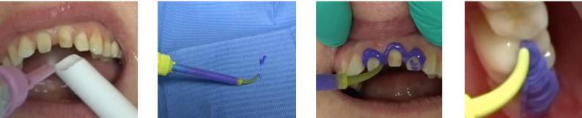

Start of the intra oral applications, simultaneously with filling the impression tray, continued by applying the wash on/in the occlusal fissures to avoid “air bubbles“ after pouring in the occlusal area of the working model.

Remove cotton wool rolls, place the tray, filled with adequate impression material in the mouth, taking care to keep the tray in a steady and stable position. It is important to allow 3-4 seconds for complete and accurate positioning of the tray.

To achieve maximum dynamic pressure, the upper tray should initially be placed distally.
Lower trays should initially be placed anteriorally.

The time taken from when intra oral application commences must not exceed 1 min 20 sec. including placement of the tray. The setting times are always measured at 23°C, this means that after 1 min 20 sec. (from the start of any intraoral application) the impression material will commence its set.

A mouth mirror can prove useful in helping to remove any excess material. The practitioner should keep a steady hold of the impression tray until the end of the total setting time.

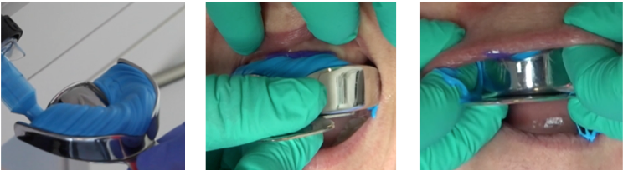

Remove and check the impression
Carefully remove the impression once the material has fully cured according to the direction of the tooth axis, rinse the impression with water and dry it. Check the impression; if preparation margin are clearly reproduced followed by disinfection of the impression.

Pouring the impression
Do not store the impression tray on the impression material to prevent deformation.
Adhere to the elastic recovery periods prior to pouring the model it is suggested that models should not be poured before 30 minutes after removing out of the mouth, however thanks to its elastomer properties Identium can be poured without waiting time.

